**Apache**

1. sudo apt-get install apache2
2. sudo apt update
3. sudo vim /etc/apache2/ports.conf
4. set port to 8080 (use root privilege if needed to save - $Sudosu)



1. cd /var/www/html
2. create or replace the index file to what we want
3. sudo vi index.html
4. cd /etc/apache2/sites-available
5. sudo vim 000-default.conf
   1. change 80 to 8080

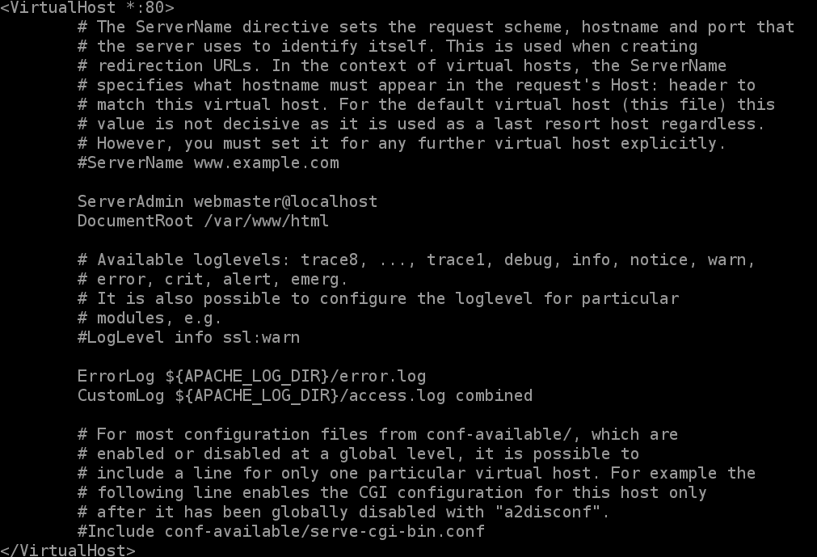

1. sudo a2ensite 000-default.conf
2. sudo apache2ctl configtest
3. sudo systemctl reload apache2
4. sudo systemctl status apache2
5. sudo apt install net-tools
6. sudo netstat –tlpn

Apache 2 should run on port 8080

## Nginx

1. sudo apt install nginx
2. sudo apt update
3. cd /usr/share/nginx/html/
4. Create an Index file we want here
5. cd /etc/nginx/sites-available/
6. sudo vim default
   1. change root to /usr/share/nginx/html/

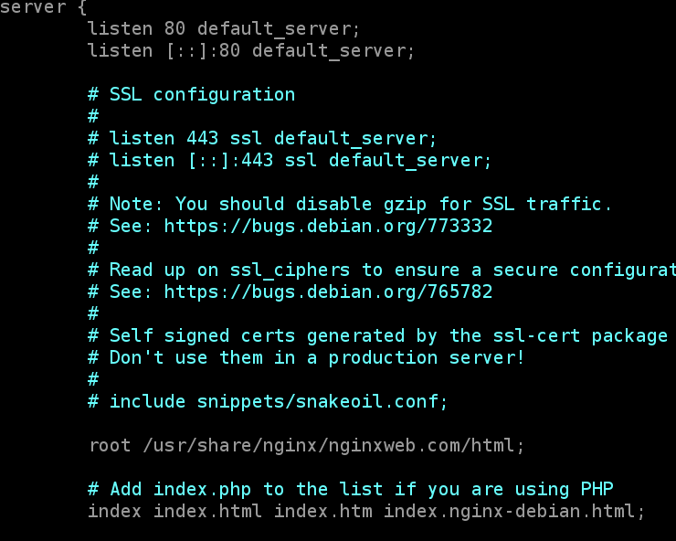

*(here I have used separate folder/domain for nginx website- it can be done directly without that too)

server{

listen 80 default_server;

listen [::]:80 default_server;

root /usr/share/nginx/html;

index index.html index.html;

server_name _;

location / {

try_files $uri $uri/ =404;

}

}

1. sudo rm /etc/nginx/sites-enabled/default
2. sudo ln –s/etc/nginx/sites-available/default /etc/nginx/sites-enabled/default
3. sudo nginx –t
4. sudo systemctl reload nginx
5. sudo systemctl status nginx
6. sudo netstat–tlpn

nginx should run on port 80